**“Mary Jane? That’s like my favourite name:” Exploring the correlation between**

**cannabis consumption and anxiety among university students.**

Dalmar Yusuf

Department of Psychology, University of British Columbia

PSYC 277: Behavioural and Neuroscientific Research Methods

Dr. Ipek Oruc

December 7, 2022

**Introduction**

With the legalisation of weed in October of 2019, cannabis-containing products have become more accessible than ever to millions of people across Canada. Although many consider cannabis not as harmful as other recreational drugs, a growing number of research is pointing to its negative impacts on mental health outcomes (Gobbi et al., 2019; Karila et al., 2014; McDonald et al., 2019; Petrilli et al., 2022; Sharpe et al., 2022) as well as developing brains (Owens et al., 2022). Not only has THC, the main psychoactive ingredient in marijuana, been associated with increasing anxiety among its consumers (Petrilli et al., 2022; Sharpe et al., 2020), but premature thinning of the prefrontal cortex has also been found to correlate with cannabis consumption during adolescence (Owens et al., 2022). As such, since cannabis products are legally accessible to adolescents before their brains are able to fully develop, it is important to investigate its effects on this particularly vulnerable demographic, which includes undergraduate university students. We conducted a small-scale survey in order to determine if cannabis consumption had an effect on anxiety levels among university students. With previous literature in mind, hypothesised that increased consumption of cannabis-containing products would correlate with higher scores on the GAD-7.

**Method**

**Participants**

Our intended sample size was 150 students generalizable to the entire UBC undergraduate population, though we were only able to collect 119. Our sample demographic was primarily female (64%), mostly in the faculty of science, and with a mode age of 19. Our sampling method was convenience sampling through personal Instagram stories as well as platforms such as Discord and Piazza. Considering our method of sampling, our sample was representative of the UBC Neuroscience undergraduate program cohort.

**Measures**

Our operational definition for anxiety level was a numeric score on the GAD-7, a seven-question test developed by Spitzer et al. (2006) which evaluates symptoms of generalised anxiety disorder. Frequency of cannabis consumption was defined as incidence of using cannabis products within a 3-month time frame. We categorically simplified frequency into four groups: (1) not all; (2) 1-3 times per month, corresponding to *monthly*; (3) 1-4 times per week, corresponding to *weekly*; and (4) 5-7 times per week, corresponding to *daily*.

**Procedure**

Our data collection method comprised of a Qualtrics survey consisting of three parts: (1) a demographics questionnaire asking respondents for consent, their age, their gender, and a declaration of UBC student status, as well as faculty; (2) an anxiety level questionnaire adapted from Spitzer et al. (2006, see Appendix); and (3) a question evaluating their frequency of cannabis consumption. If any respondents did not consent to participating in the study, the survey was programmed to close automatically. Further, non-UBC respondents were not included. The Qualtrics survey was sent on the aforementioned platforms, and we conducted our statistical analyses via Microsoft Excel.

**Results**

The no frequency group had *n =* 72 participants with moderate anxiety levels (*M =* 8.68, *SEM* = 0.64), the low frequency group had *n =* 30 participants with high anxiety levels (*M* = 11.17, *SEM* = 1.81), the moderate frequency group had *n =* 10 participants with moderate anxiety levels (*M* = 8.40, *SEM* = 0.81), and the high frequency group had *n =* 7 participants also with moderate anxiety levels (*M =* 7.14, *SEM* = 2.03). Seeing as we wished to determine if there was a statistically significant difference of mean anxiety scores between multiple levels of our categorised variable, we determined that a one-way ANOVA test was most appropriate. We were unable to reject the null hypothesis that there were no differences in group means at a 0.05 significance level, *F*(3, 115) = 1.951, *p* = .125.

**Figure 1**

*Mean anxiety score compared to frequencies of cannabis consumption among UBC students*

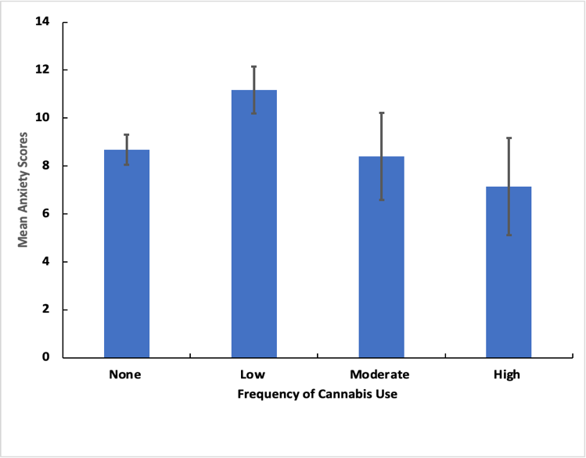

*Note.* Mean anxiety scores derived from the GAD-7 (Spitzer et al., 2006) compared to frequency of cannabis use in the past three months. Low frequency is described as 1-3 days per month, moderate frequency is described as 1-4 days per week, and high frequency is described as 5-7 days per week. Error bars represent the standard error of the mean.

**Discussion**

These results answer our research question by demonstrating that there is no statistically significant difference in anxiety levels among university students relative to frequency of cannabis consumption. Our hypothesis that increased cannabis consumption would correlate to higher anxiety levels among university students was not supported by the results of our study, despite general academic consensus that adolescent cannabis consumption is correlated to poorer mental health outcomes (Gobbi et al., 2019; Karila et al., 2014; McDonald et al., 2019; Petrilli et al., 2022; Sharpe et al., 2022). Considering that multiple systematic reviews have been carried out across decades on this topic, we consider the inconclusive results of our study as outliers owed to limitations in our experimental design.

***Sample Sizes***

A large limitation to our study were our sample sizes. Though we were able to receive appropriate sample sizes for our no frequency (*n =* 70) and low frequency (*n* = 30) groups, we had very few respondents in our moderate (*n* = 11) and high frequency (*n* = 7) categories; this meant that our means and standard errors in the higher frequency groups were overly dependent on the individual sample distributions, which may not have been representative of the true population distribution. While the lower frequency groups had sufficient responses to demonstrate a positive correlation, the higher frequency categories did not have enough responses to properly establish a relationship, which likely led to our failure to reject the null hypothesis. Increasing sample sizes across the groups could have resulted in more accurate findings.

***Confounding Cohort Stressors***

Since our demographic was composed of members of largely the same cohort of university students, they would have been exposed to similar stressors during the same time period, which likely resulted in similar anxiety levels among the participants, independent of cannabis consumption. Examples of stressors include typical academic pressures, but also institution-specific stressors such as food insecurity as well as housing insecurity (Turdy et al., 2022); survey questions on potential confounding stressors could have been useful to evaluate these potential confounds. This brings to the forefront the question of directionality: are students consuming cannabis because they are anxious, or are they anxious because they consume cannabis-containing products? Considering the physiological markers for stress would be at play here, a clinical approach would be required to answer this question beyond the scope of a short survey, especially since different cannabinoids have been found to both reduce as well as intensify anxiety in clinical studies (Petrilli et al., 2022; Sharpe et al., 2020). Future studies can also explore potential confounding stressors such as food and housing insecurity as well as other confounding substances such as alcohol and caffeine, as those have been found to affect anxiety levels as well (Evans et al., 2020; Richards & Smith, 2015).

**References**

Evans, O., Rodríguez-Borillo, O., Font, L., Currie, P. J., & Pastor, R. (2020). Alcohol Binge Drinking and Anxiety-Like Behavior in Socialized Versus Isolated C57BL/6J Mice. *Alcoholism, clinical and experimental research*, *44*(1), 244–254. <https://doi.org/10.1111/acer.14236>

Gobbi, G., Atkin, T., Zytynski, T., Wang, S., Askari, S., Boruff, J., Ware, M., Marmorstein, N., Cipriani, A., Dendukuri, N., & Mayo, N. (2019). Association of Cannabis Use in Adolescence and Risk of Depression, Anxiety, and Suicidality in Young Adulthood: A Systematic Review and Meta-analysis. *JAMA psychiatry*, *76*(4), 426–434. <https://doi.org/10.1001/jamapsychiatry.2018.4500>

Karila, L., Roux, P., Rolland, B., Benyamina, A., Reynaud, M., Aubin, H. J., & Lançon, C. (2014). Acute and long-term effects of cannabis use: a review. *Current pharmaceutical design*, *20*(25), 4112–4118. <https://doi.org/10.2174/13816128113199990620>

McDonald, A. J., Roerecke, M., & Mann, R. E. (2019). Adolescent cannabis use and risk of mental health problems-the need for newer data. *Addiction (Abingdon, England)*, *114*(10), 1889–1890. <https://doi.org/10.1111/add.14724>

Owens, M. M., Albaugh, M. D., Allgaier, N., Yuan, D., Robert, G., Cupertino, R. B., Spechler, P. A., Juliano, A., Hahn, S., Banaschewski, T., Bokde, A. L. W., Desrivières, S., Flor, H., Grigis, A., Gowland, P., Heinz, A., Brühl, R., Martinot, J. L., Martinot, M. P., Artiges, E., … IMAGEN Consortium (2022). Bayesian causal network modeling suggests adolescent cannabis use accelerates prefrontal cortical thinning. *Translational psychiatry*, *12*(1), 188. <https://doi.org/10.1038/s41398-022-01956-4>

Petrilli, K., Ofori, S., Hines, L., Taylor, G., Adams, S., & Freeman, T. P. (2022). Association of cannabis potency with mental ill health and addiction: a systematic review. *The lancet. Psychiatry*, *9*(9), 736–750. <https://doi.org/10.1016/S2215-0366(22)00161-4>

Richards, G., & Smith, A. (2015). Caffeine consumption and self-assessed stress, anxiety, and depression in secondary school children. *Journal of psychopharmacology (Oxford, England)*, *29*(12), 1236–1247. <https://doi.org/10.1177/0269881115612404>

Sharpe, L., Sinclair, J., Kramer, A., de Manincor, M., & Sarris, J. (2020). Cannabis, a cause for anxiety? A critical appraisal of the anxiogenic and anxiolytic properties. *Journal of translational medicine*, *18*(1), 374. <https://doi.org/10.1186/s12967-020-02518-2>

Spitzer, R. L., Kroenke, K., Williams, J. B., & Löwe, B. (2006). A brief measure for assessing generalized anxiety disorder: the GAD-7. *Archives of internal medicine*, *166*(10), 1092–1097. <https://doi.org/10.1001/archinte.166.10.1092>

Turdy, D., Sahbaei, T., Caguiat, I. D., & Reyeros, J. (2022). *2022 AMS Academic experience survey report*. Alma Mater Society of UBC, Office of the Vice President Academic and University Affairs. <https://www.ams.ubc.ca/wp-content/uploads/2022/08/2022-AMS-Academic-Experience-Survey-Report.pdf>

**Appendix**

*Qualtrics survey question on anxiety*

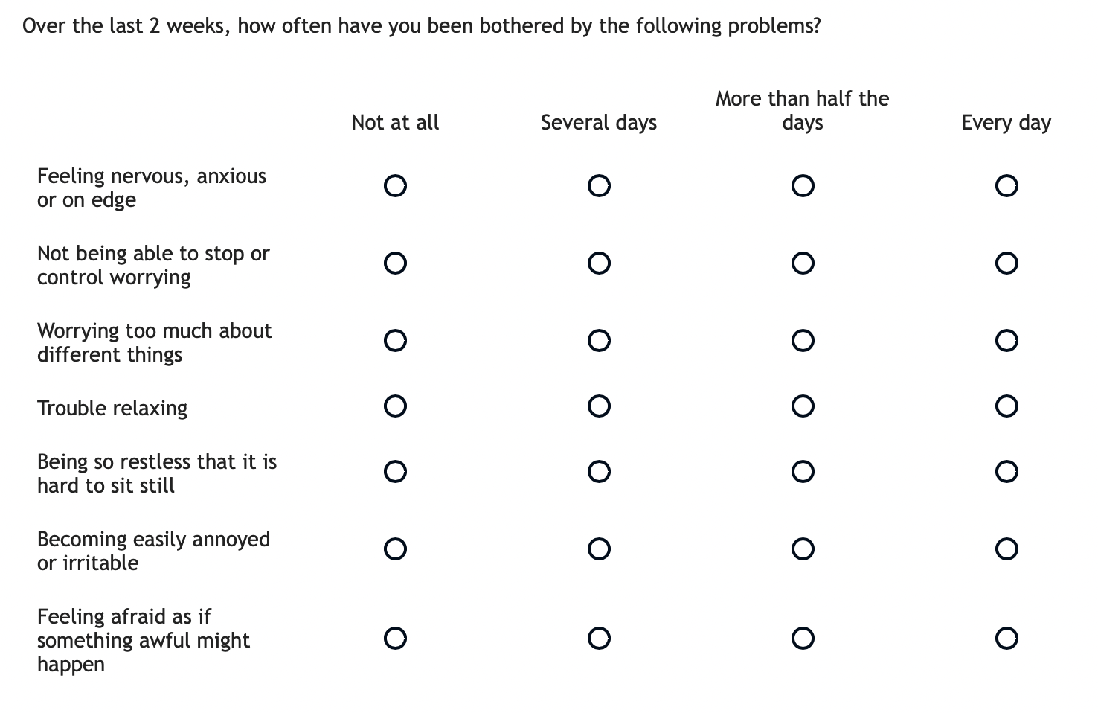

*Note.* Questions adapted from Spitzer et al., 2022.